- Launch one EC2 using Amazon Linux 2 image and add a script in user data to install Apache.

1. Log in to the AWS Console and open EC2.
2. Click Launch instance.
3. Enter the instance name as apache-server.
4. Select Amazon Linux 2 AMI.
5. Select the instance type t3.micro if available.
6. Select your existing key pair.
7. Allow SSH (port 22) and HTTP (port 80) in the security group.
8. Open Advanced details and find the User data field.
9. Write the script in the user data
10. Click Launch instance.
11. Wait until the instance is running.
12. Copy the Public IPv4 address.
13. Open a browser and enter http://YOUR-PUBLIC-IP.

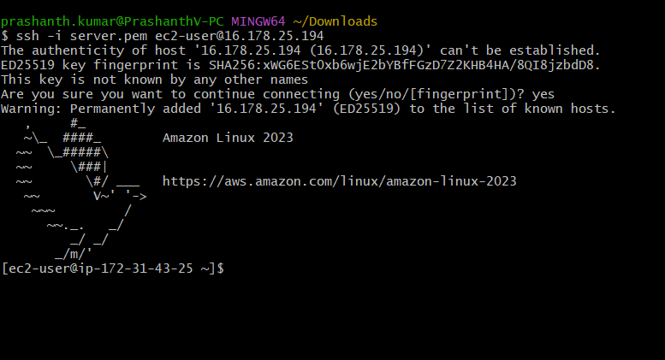
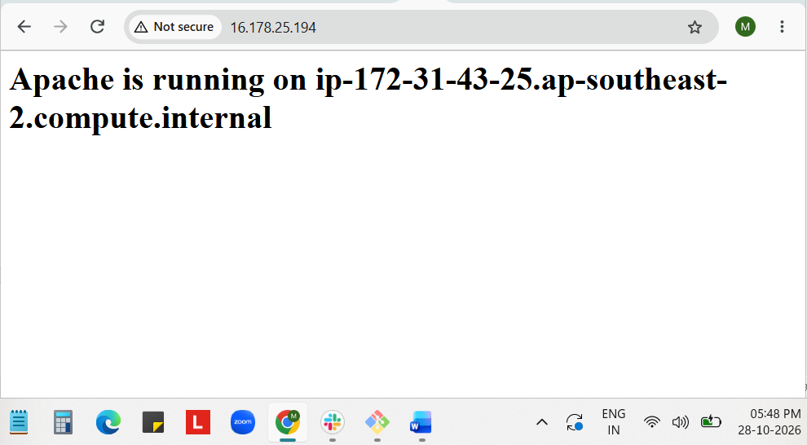

- Launch one EC2 using Ubuntu image and add a script in user data to install Nginx.
1. Log in to the AWS Console and open EC2.
2. Click Launch instance.
3. Enter the instance name as nginx-server.
4. Select the Ubuntu Server AMI.
5. Select an available instance type.
6. Select your existing key pair.
7. Allow SSH (port 22) and HTTP (port 80) in the security group.
8. Open Advanced details and find the User data field.
9. Write the userdata script
10. Click Launch instance.
10. Wait until the instance is running and the status checks pass.
11. Copy the Public IPv4 address.
12. Open a browser and enter http://YOUR-PUBLIC-IP.

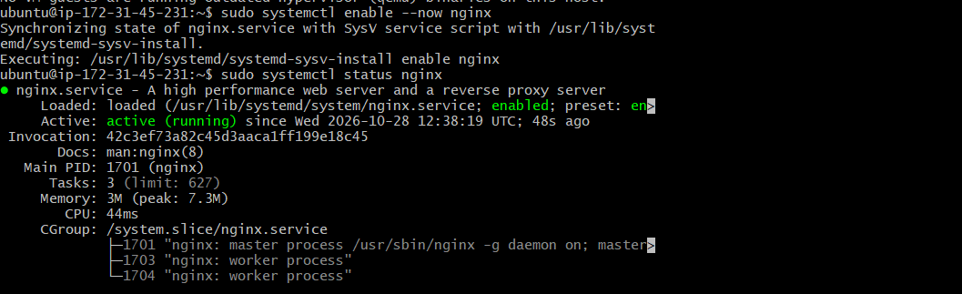

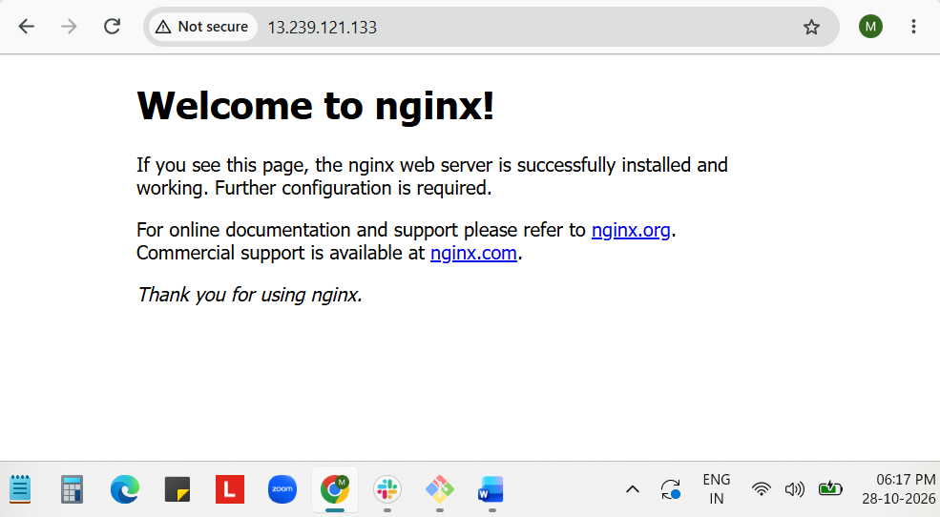

Error:-
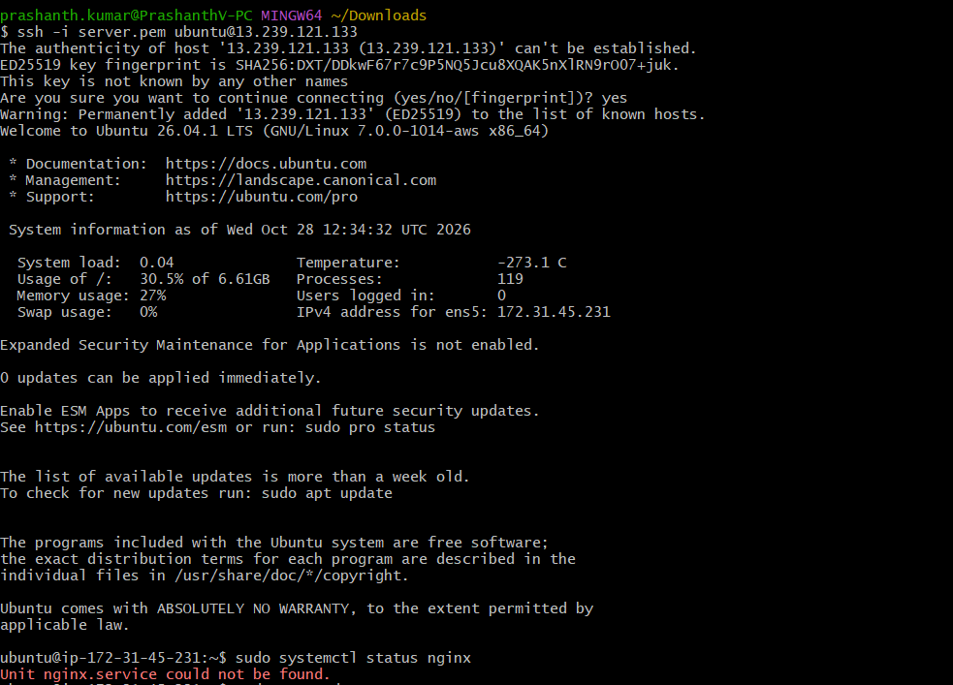

- Launch one Windows server and install Tomcat on Windows.
1. Open EC2 → Instances → Launch instances.
2. Enter a name, such as tomcat-windows.
3. Under Application and OS Images, choose a Windows Server image.
4. Select an instance type and create or select a key pair. You will use the .pem file to
decrypt the Windows Administrator password.
5. Under Network settings, allow:
○ RDP, TCP 3389, from My IP.
○ Custom TCP, TCP 8080, from My IP for a private Tomcat test.
6. Launch the instance. Wait for it to pass its status checks.
7. Select the instance and choose Connect → RDP client → Get password. Use the
launch key pair’s .pem file to decrypt the password.
8. Connect to the Windows desktop as Administrator.
9. Inside Windows, install a 64-bit Java JDK. Tomcat 10.1 requires Java 11 or later.
10. Download the Windows Service Installer for Tomcat 10.1 from the official Apache
Tomcat download page. Run the installer and keep the default HTTP port, 8080.
11. In Windows Defender Firewall with Advanced Security, create an inbound rule for
TCP 8080

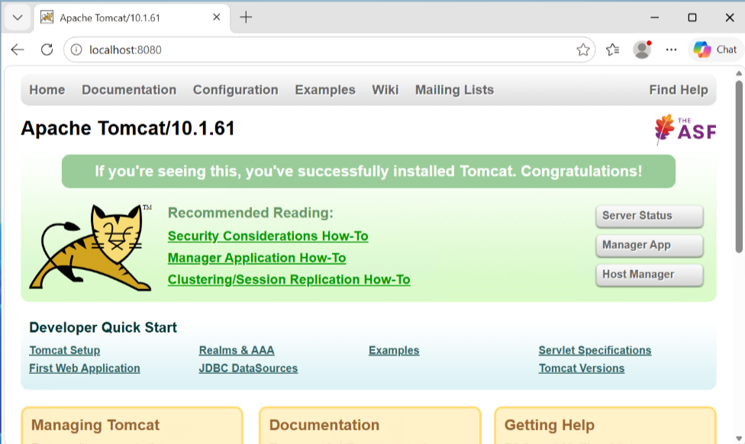

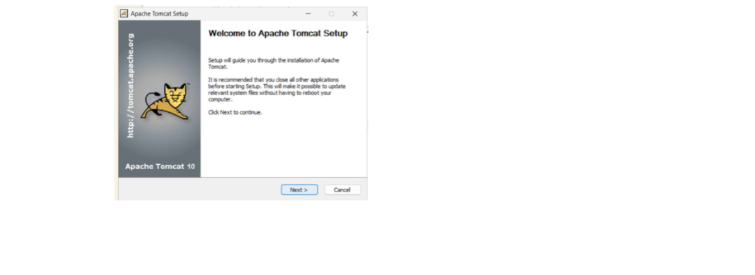

- Take a snapshot of the instance created in Task 1.

Log in to the AWS Console.
Search for EC2 and click Instances.
Select the instance you created in Task 1 Server
in the instance details, find the Storage tab.
Click the Volume ID linked to the instance.
Select the volume.
Click Actions → Create snapshot.
Enter a description, such as Server-EC2-Snapshot.
Click Create snapshot.
Go to EC2 → Snapshots.
Check that your snapshot status changes to Completed.
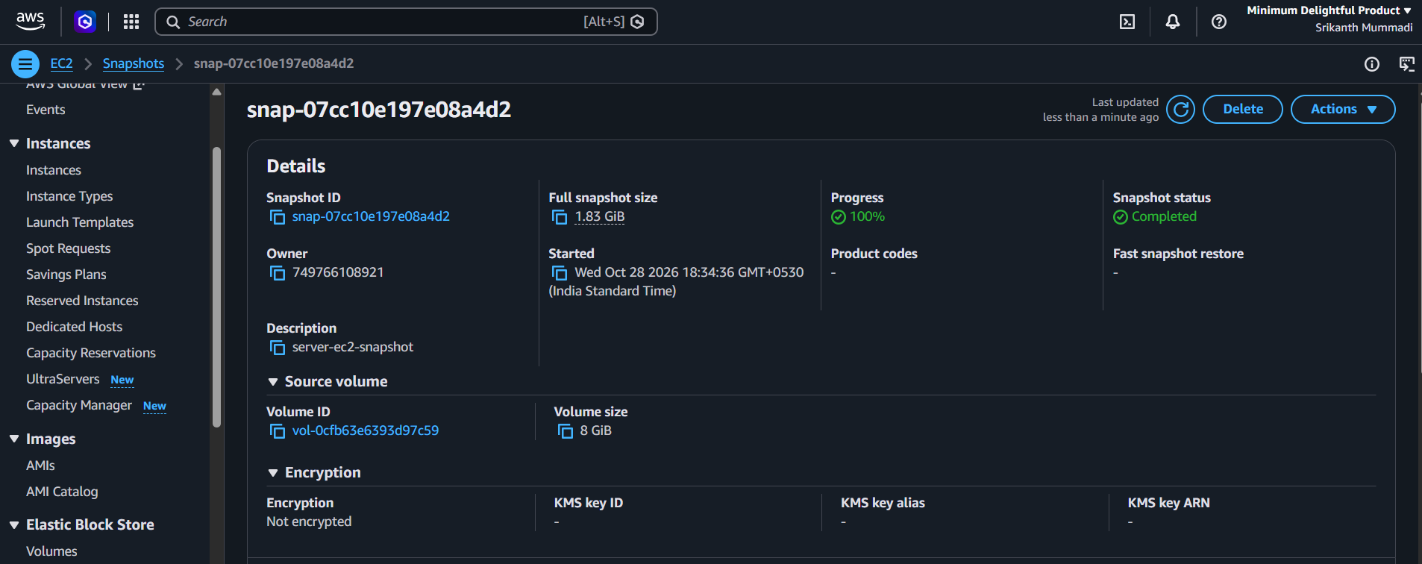

- Assign passwordless authentication for the EC2 created in Task 2.

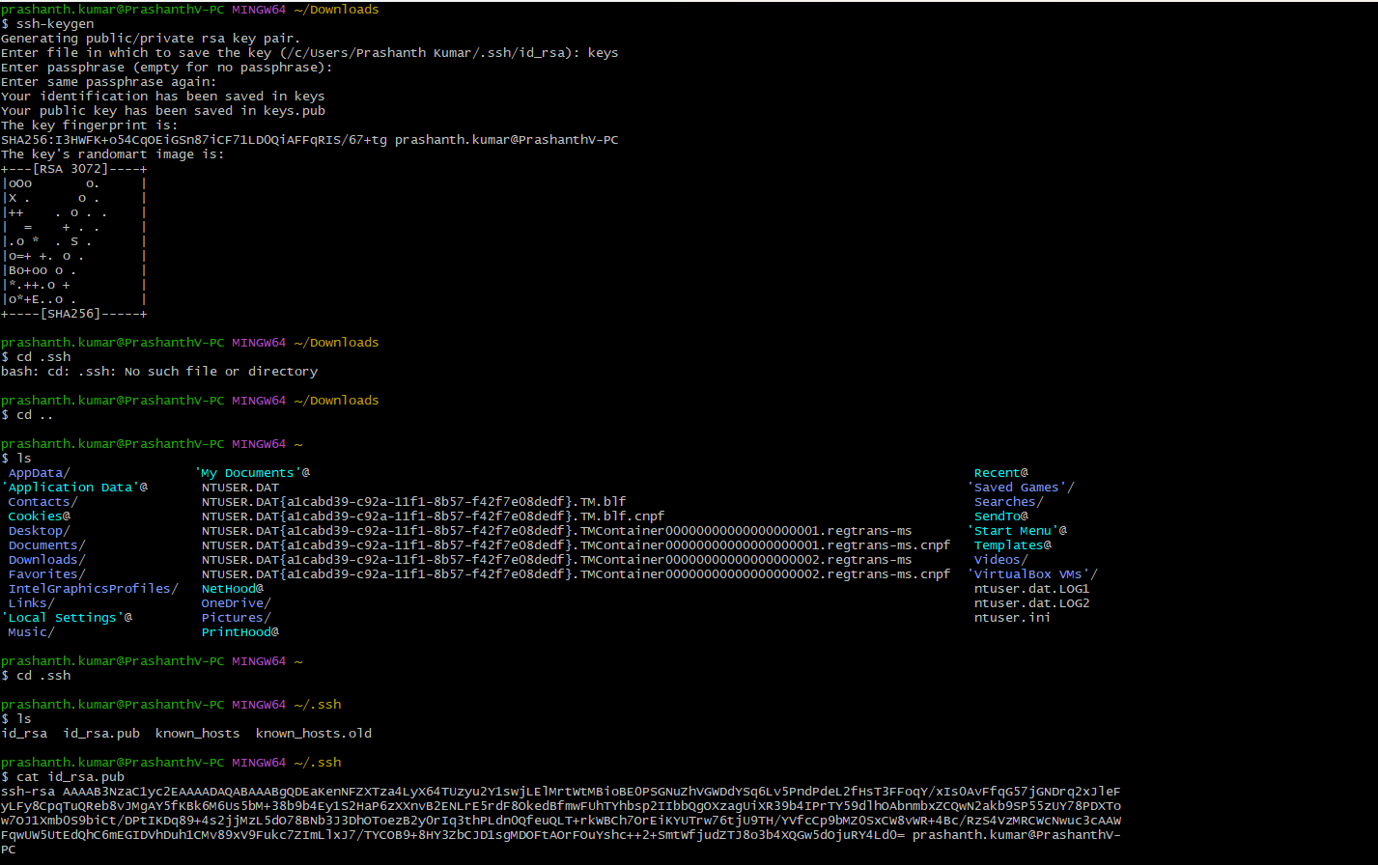

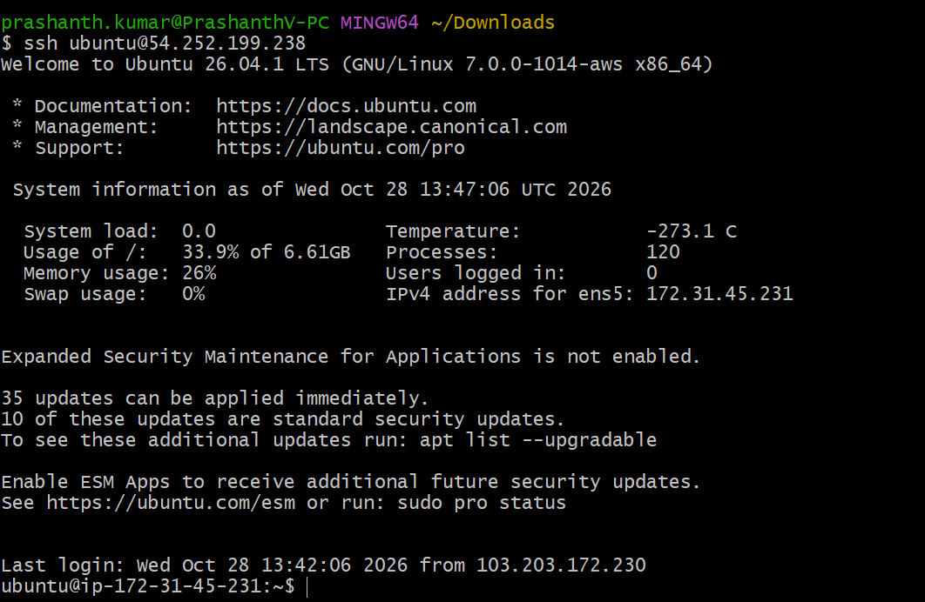

- Launch any EC2 using the spot purchasing option.

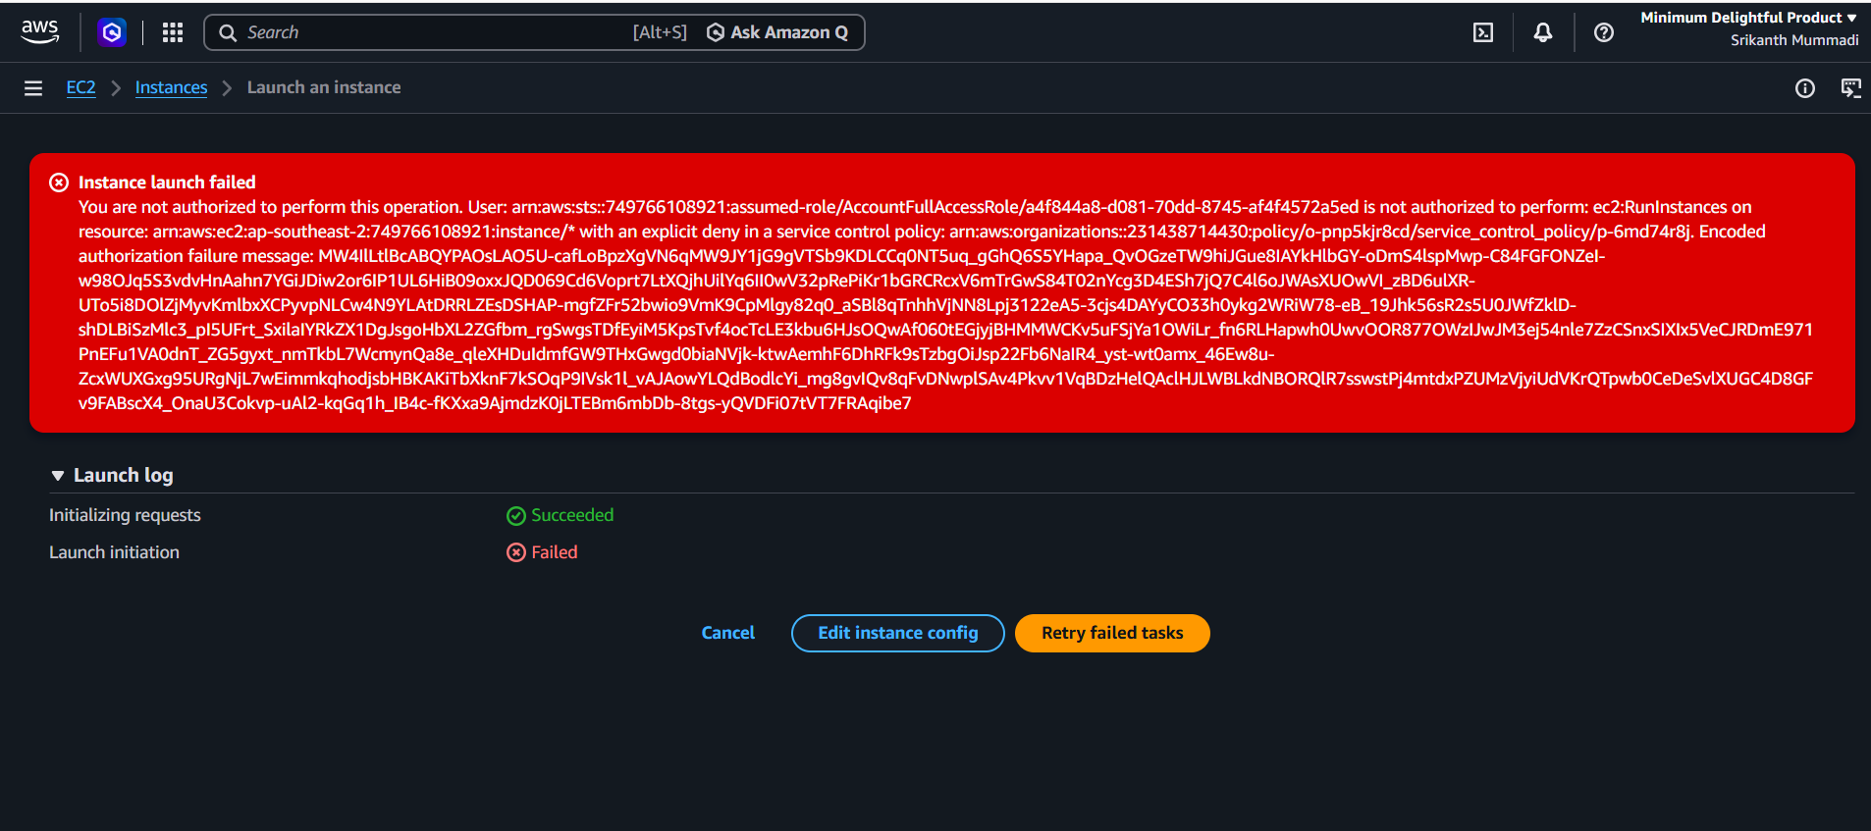

- Enable termination policy on the EC2 created in Task 2.
• Log in to the AWS Management Console.
• Navigate to the EC2 Dashboard.
• Select Instances from the left-side navigation panel.
• Identify and select the EC2 instance created in Task 2.
• Click Actions.
• Select Instance settings.
• Click Change termination protection.
• Enable Termination protection.
• Click Save.
• Verify that termination protection is enabled for the selected EC2 instance.

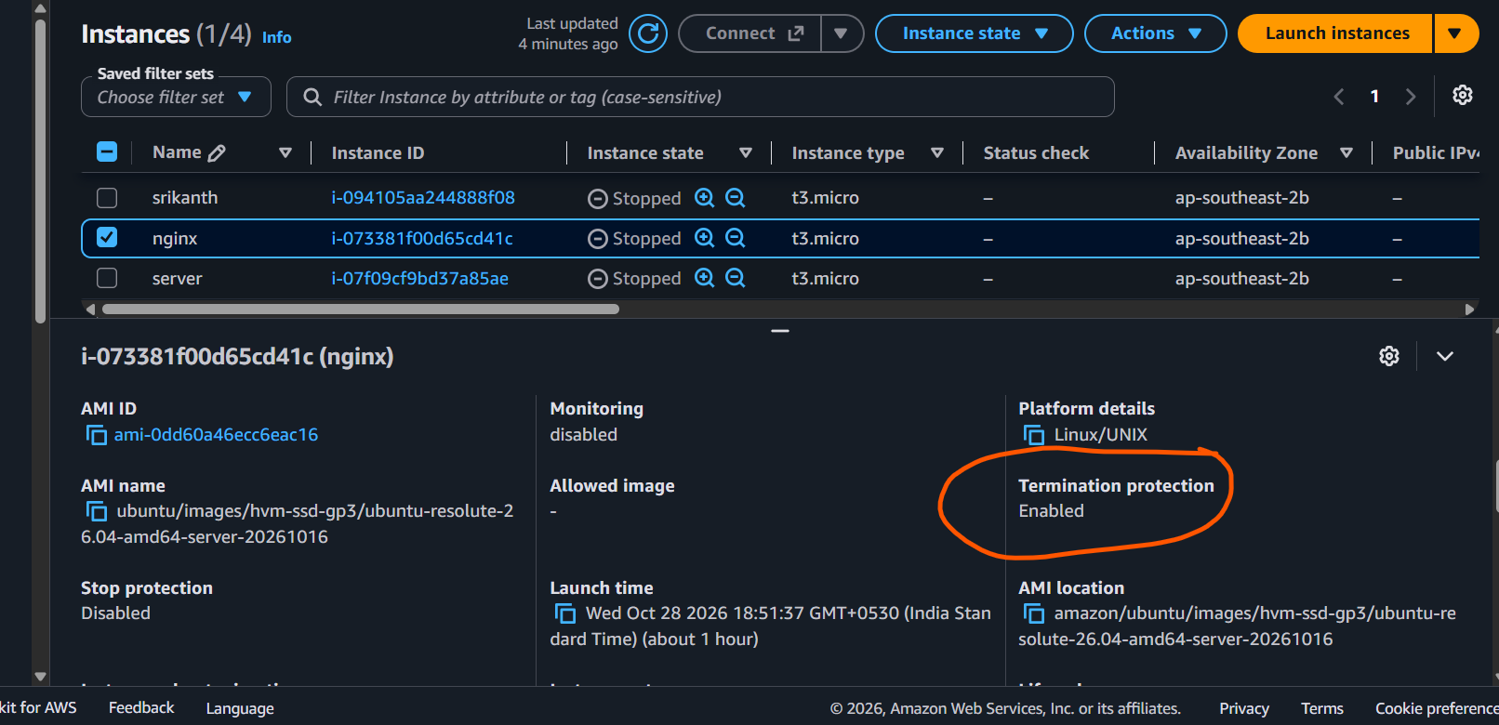

- Launch one EC2 using AWS CLI.
• Install AWS CLI on your Windows laptop.
• Open Command Prompt or Git Bash.
• Verify that AWS CLI is installed successfully.
• Open AWS IAM Console and create an IAM user with EC2 permissions.
• Generate the Access Key ID and Secret Access Key.
• Configure AWS CLI using your AWS credentials.
• Select the default AWS region (e.g., Mumbai – ap-south-1).
• Create a key pair for EC2 access.
• Identify the Amazon Linux or Ubuntu AMI ID.
• select the EC2 instance type (e.g., t2.micro).
• Launch one EC2 instance using AWS CLI.
• Verify the instance ID and instance state.
• Check the EC2 instance in the AWS Management Console.

